Third-Party Web Tracking

|  |
| --- |
| Copyrights 2016-2017 Frank Xu, Bowie State University.  The lab manual is developed for teaching cyber-related courses based on http://www.cis.syr.edu/~wedu/seed/. Comments and suggestions can be sent to wxu@bowiestate.edu |

**Introduction**

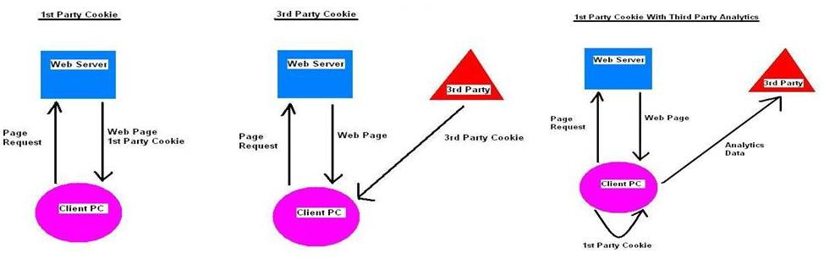

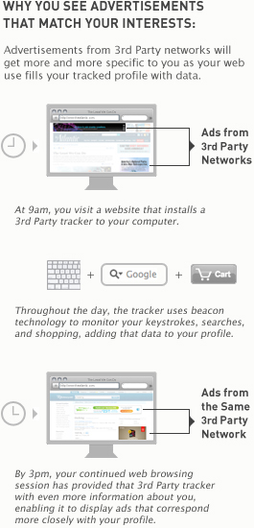

**Lab Environment**

We have created two accounts in the VM. The usernames and passwords are listed in the following:

* + User ID: root, Password: *seedubuntu*.
  + Note: Ubuntu does not allow root to login directly from the login window. You have to login as a normal user, and then use the command **su** to log into the root account.
  + User ID: seed, Password: *dees*

**Task 1: Understand How Web Tracking Work**

1. Clear web history and cookies

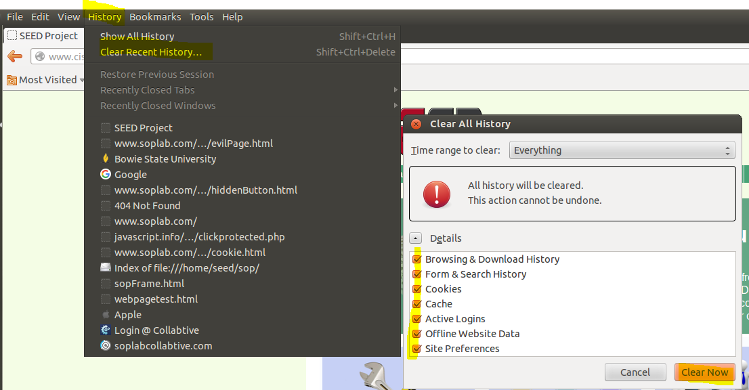

1. Starting the Apache Server



1. Open website and login as Alice

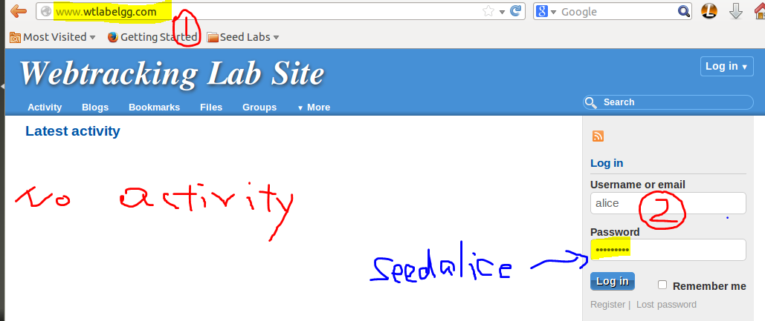

1. Open Firefox and open the **CameraStore**, **MobileStore**, **ElectronicStore** and **ShoeStore** websites

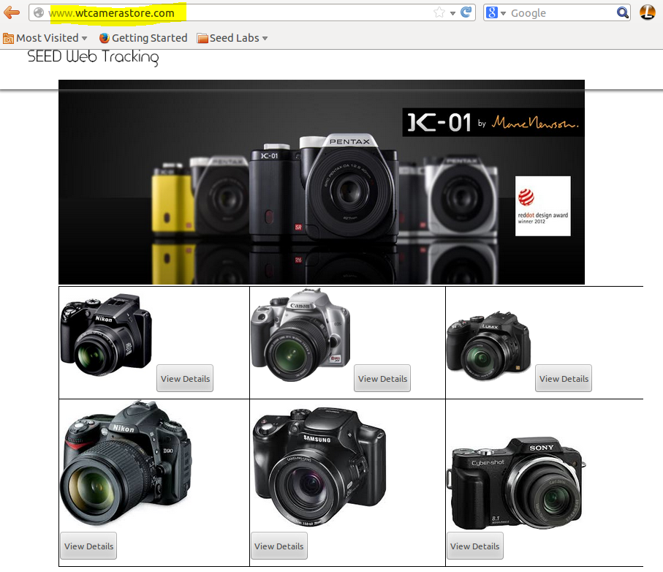

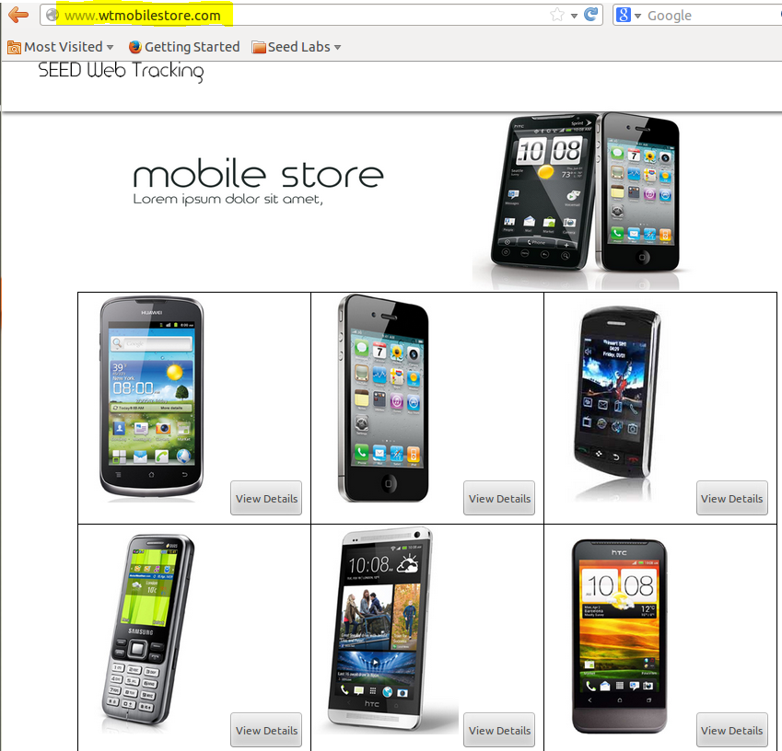

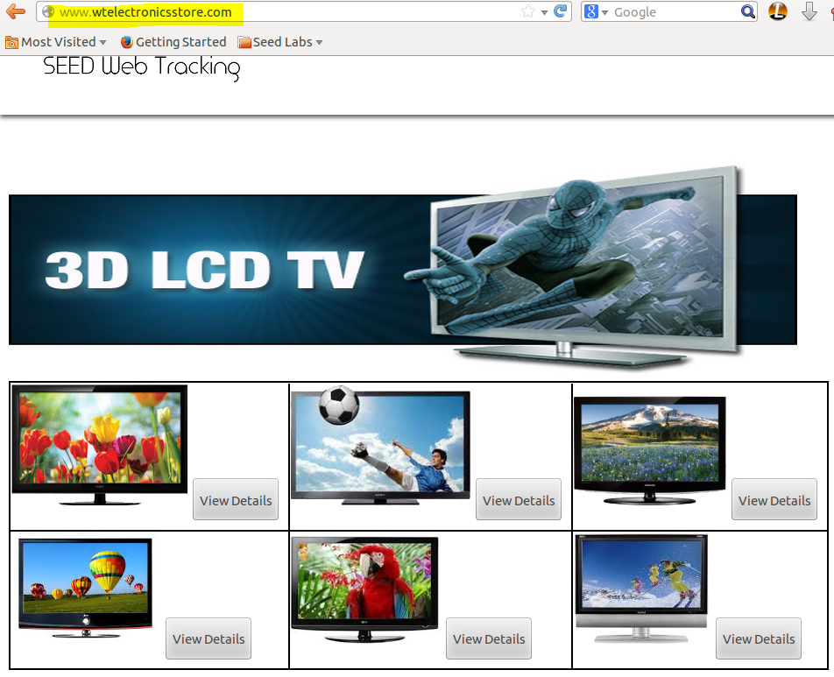

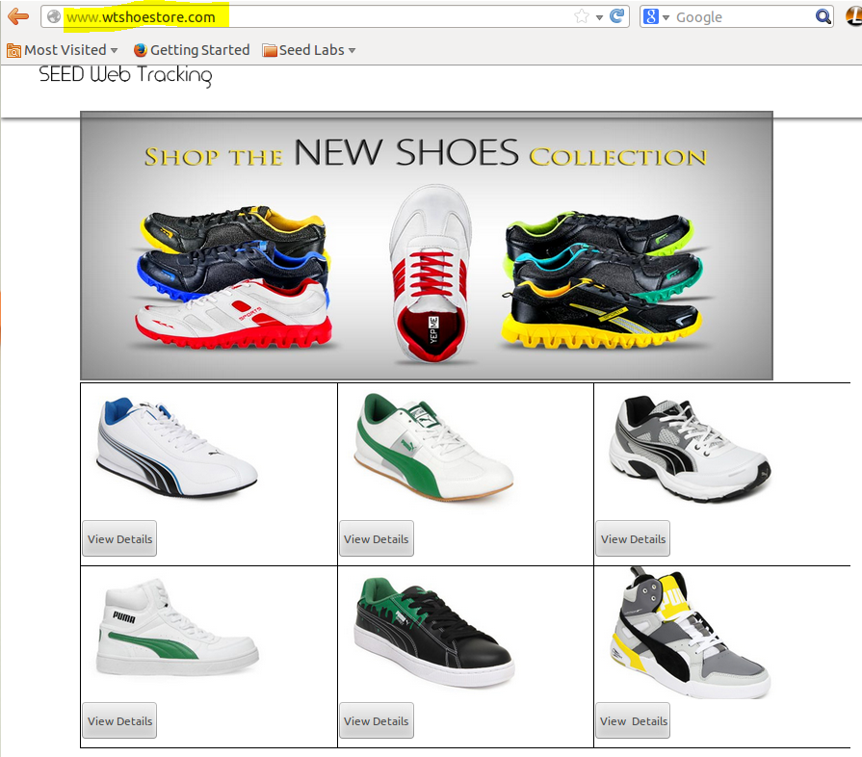

1. Click **View Details** of an item on [www.wtcamerastore.com](http://www.wtcamerastore.com)
2. Refresh [www.wtlabelgg.com](http://www.wtlabelgg.com). The item shows on the page

|  |  |
| --- | --- |
|  |  |

1. Question: Repeat steps 5 and 6 with a different item. Describe your observation.

**Task 2: Web Tracking Using Cookies**

1. Clear web history and cookies (see Task 1)
2. Open [www.wtcamerastore.com](http://www.wtcamerastore.com) and Live HTTP header
3. Click the item on the web page. It leads to **productDetails.php**

|  |  |
| --- | --- |
|  |  |

1. Observer the captured HTTP header

|  |  |
| --- | --- |
|  |  |

1. Open [www.wtlabelgg.com](http://www.wtlabelgg.com) and Live HTTP header

|  |  |
| --- | --- |
|  |  |

1. Questions
   1. What is a User-Agent?
   2. What is a Referrer?
   3. What is Set-Cookie?
   4. What differences between POST and GET? Note: Authors of services which use the HTTP protocol SHOULD NOT use GET based forms for the submission of sensitive data, because this will cause this data to be encoded in the Request-URI.
2. ProductDetails.php sends product information and session ID to www.wtlabadserver.com



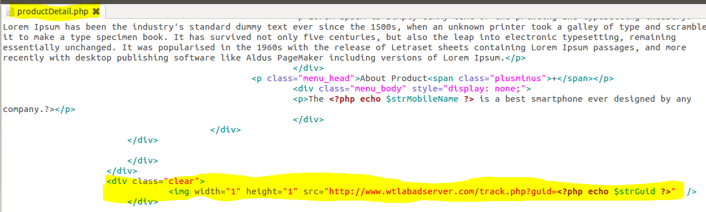

1. **www.wtlabadserver.com** receives product information and session ID sent from **ProductDetails.php** and save it to database.



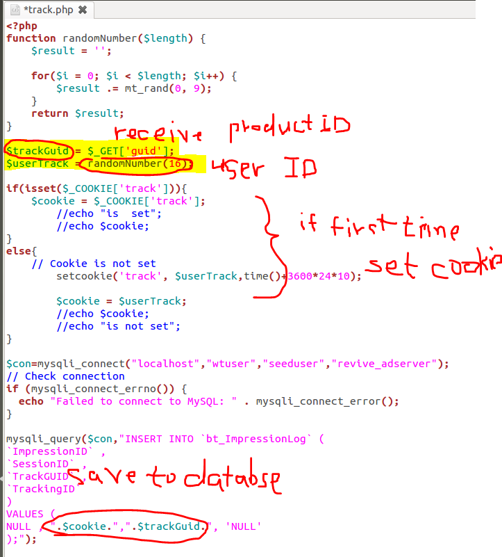

1. **www.wtlabadserver.com** displays saved product and user information from www.wtcamerastore.com

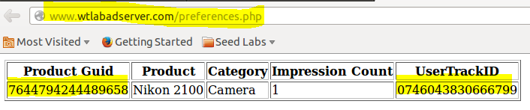

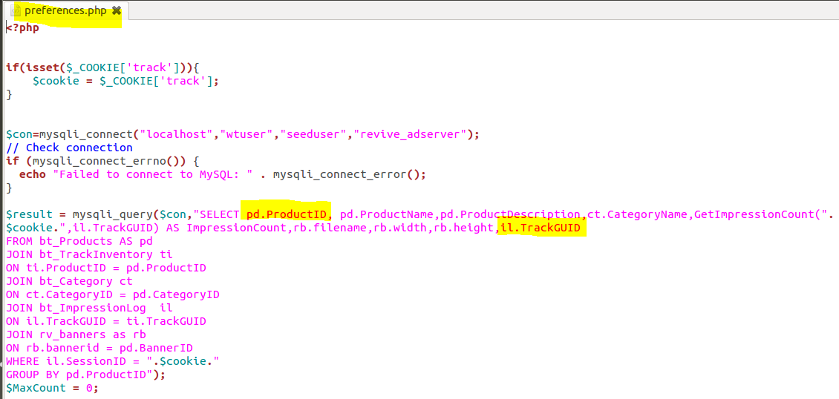

1. [www.wtlabelgg.com](http://www.wtlabelgg.com) source code displays ads



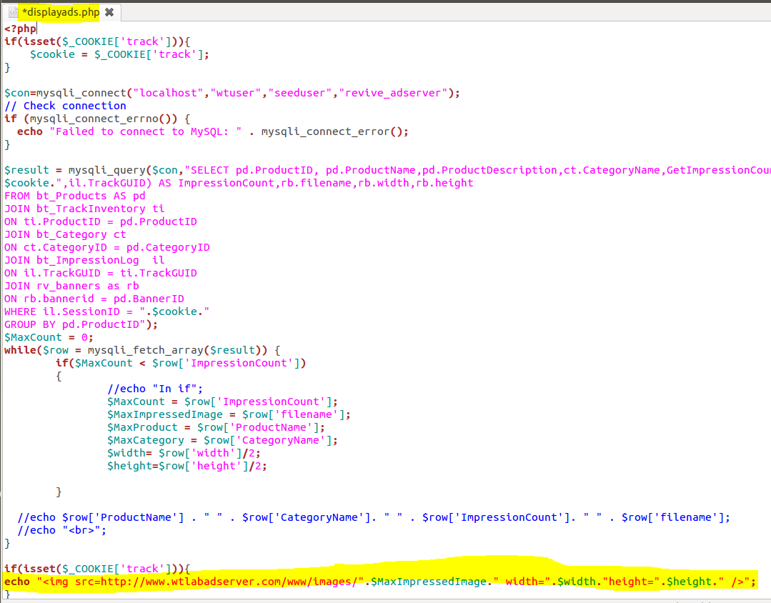

1. Question: Change Firefox to Chrome, repeat the lab and describe difference

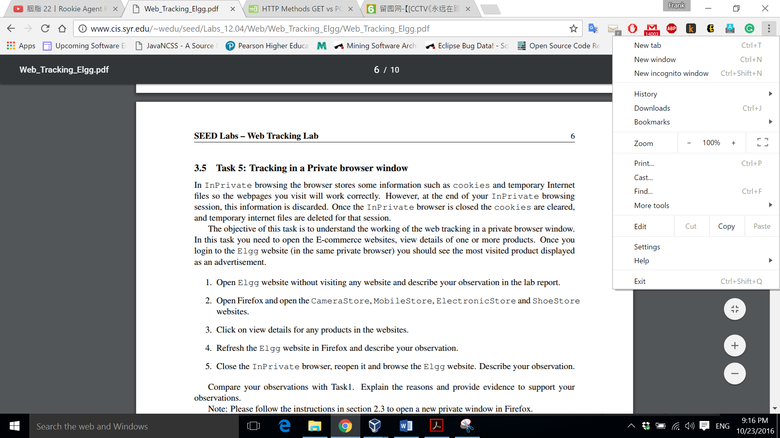

1. Question: The current [www.wtlabelgg.com](http://www.wtlabelgg.com) only displays one clicked the item. Modify the code to display multiple items you have visited in different online stores.

Reference:

* http://www.cis.syr.edu/~wedu/seed/lab_env.html
* <http://www.analytics-tools.com/2012/04/web-analytics-concepts-cookies.html>
* https://www.newfangled.com/if-they-are-watching-should-you-watch-too/